**OutPut Screenshots**

**# deployed on etherscan**

* **Asking confirmation on wallet**

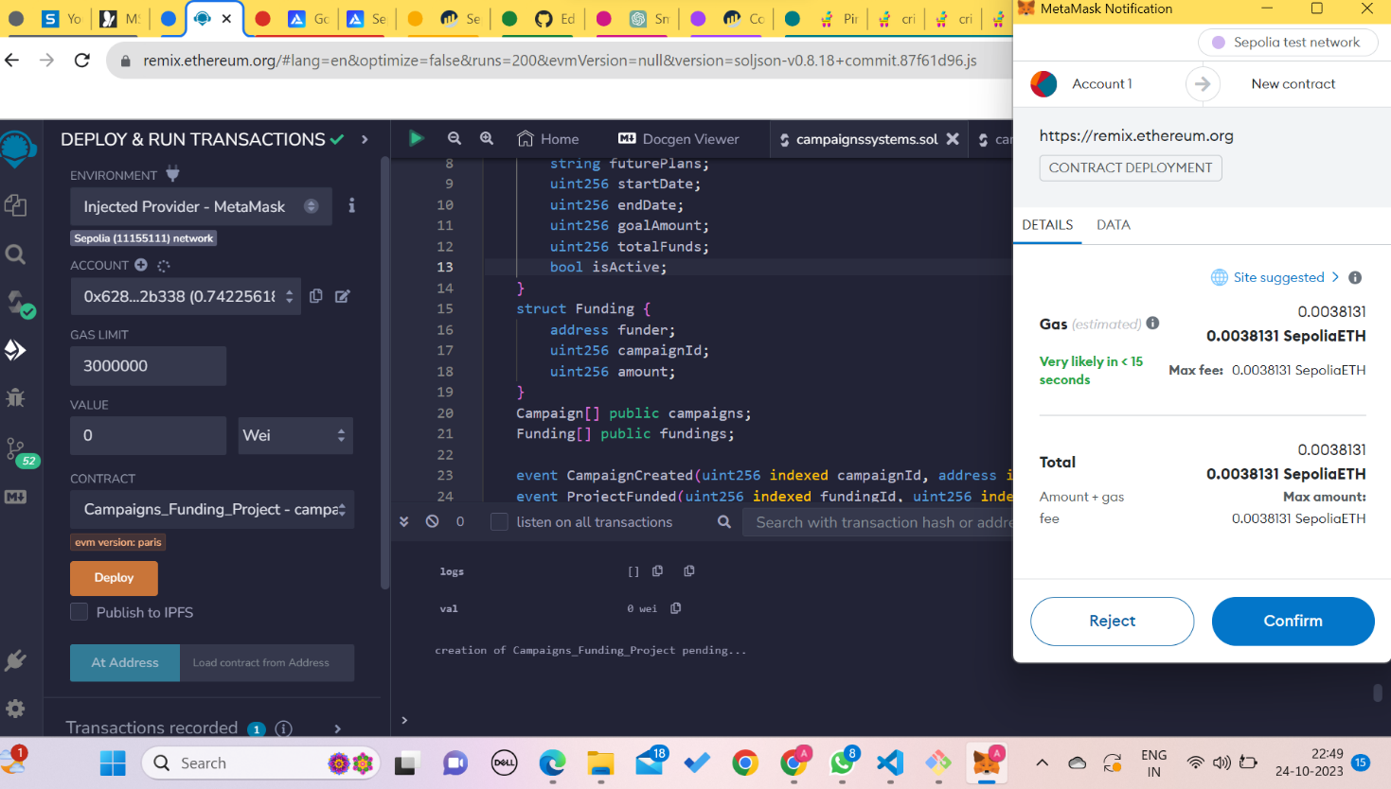

* **On etherscan**

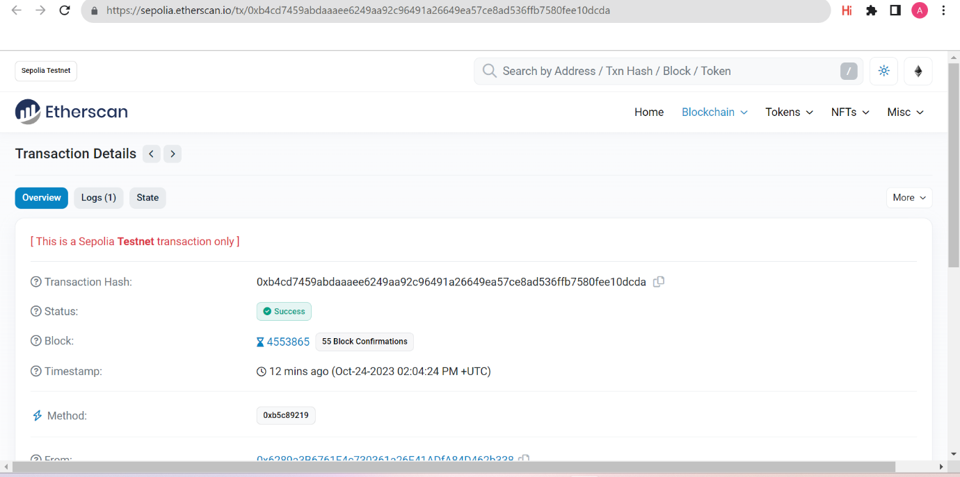

**Links are provided in readme**

* **Campaign Creation**

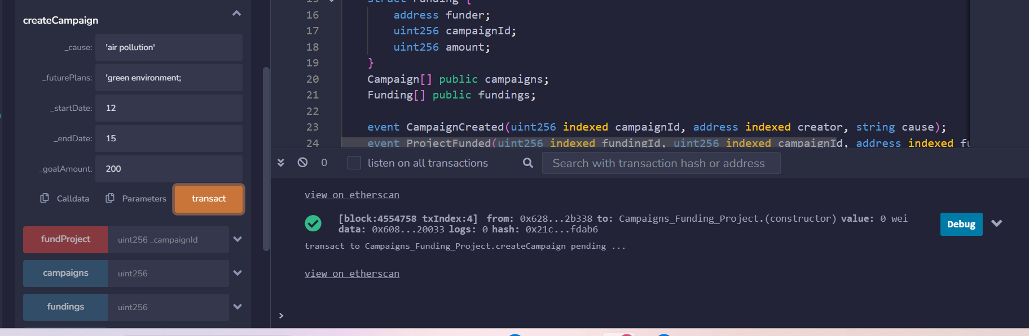

**Giving details of particular campaign based on campaign_id**

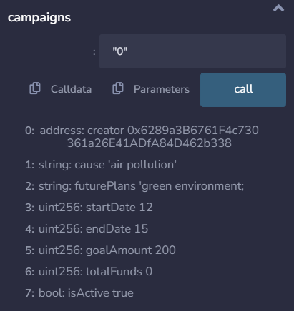

**Screenshot of etherscan – When transaction is done regarding creation of campaign**

